Source Water Protection STatement – Principle 8 CAse study – SEQ’s REsilient Rivers initiative and catchment action plans

PRINCIPLE 8
Communication with the community is vital.

OTHER RELEVANT PRINCIPLES:
Principle 6: Appropriate investment and risk-based decision-making should be followed
Principle 7: Knowing your catchment
Principle 9: The transdisciplinary and adaptive nature of source water protection should be acknowledged and practised
Principle 10: Achieving source water protection through leading the way and partnerships
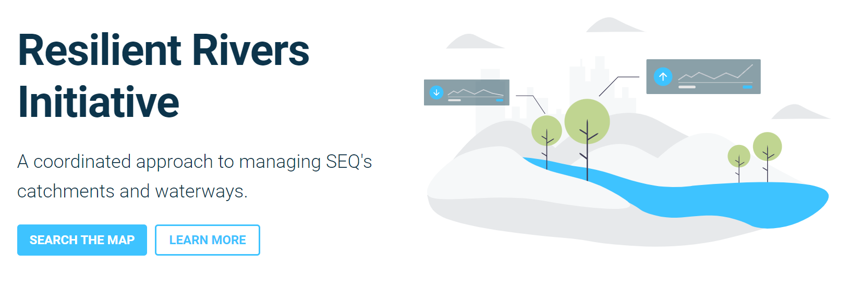

Keywords
Collaboration, engagement, communication, catchments, drinking water, erosion, flooding, partnerships, water quality, resilience

CASE STUDY DETAILS:
Year:
2015 - 2025

Location:
South East Queensland

Team:
Council of Mayors South East Queensland (CoMSEQ), Queensland Government, SEQ Water, Unitywater, Urban Utilities, Healthy Land and Water, SEQ Local Councils, catchment and peak industry organisations and the community.

CASE STUDY OUTLINE:
Key drivers:
- Flooding, poor water quality and waterway health were impacting many different stakeholders across South-East Queensland. Traditionally these issues were addressed in isolation by the different stakeholders impacted, including industry, government, and residents. However, this was problematic as the issues being tackled were influenced by broader catchment conditions which were outside of the individual stakeholder’s control. For example, sediment or salinity issues which were impacting on drinking water treatment processes were being driven by land management practices in the upper catchments.
- Traditional hard infrastructure approaches to address water quality and flooding issues were becoming costly and difficult to justify. Land-based management options (such as revegetation of floodplains and improved land use practices) were identified as potential solutions but these needed to be undertaken and managed on private land.
- Climatic extremes (droughts and floods) will continue to put pressure on the waterways in SEQ and highlights the need to build resilience into these systems. This is especially important given the important role these waterways and productive lands play in terms of water security, economic value and social benefits provided to the growing population of the region.
- There was no mechanism to support collaborative planning and investment across catchments to improve water quality, waterway health and flooding conditions.

Approach taken:
- The Resilient Rivers Initiative was developed in collaboration by the Council of Mayors (SEQ), Queensland Government, Seqwater, Healthy Land and Water, Unitywater and Urban Utilities and launched in 2014 with the following vision:
“By 2045, the catchments of South East Queensland (SEQ) will support a resilient, productive, liveable and growing region.”
- The “South East Queensland Resilient Rivers Initiative Regional Strategy” (2015-2025) supports the vision with clear goals and measures of success for the region. The Resilient Rivers Taskforce oversees the delivery of this strategy. The four goals of the Regional Strategy are:
- Keep soil on our land and out of our waterways to support agricultural productivity and improve water quality.
- Help protect our region’s water security so it can support the current and future population of South East Queensland.
- Improve the climate resilience of our region.
- Promote partnerships with strong leadership to deliver a coordinated approach to catchment management in South East Queensland.
- The Regional Strategy identifies Catchment Action Plans as the mechanism to align activities and investments.
- Catchment Action Plans have been undertaken across SEQ using similar approaches. Key steps typically include:
- Building and understanding of the catchment - Literature review and/or meetings to build understanding of catchment condition. The Queensland Government’s ‘Walking the Landscape Catchment Stories’ is a useful tool at this stage in the project. https://wetlandinfo.des.qld.gov.au/wetlands/ecology/processes-systems/water/catchment-stories/
- Identify the catchment values and issues: Identification of key catchment assets, services provided and threats is undertaken, ideally with input from the broader stakeholder group. Assets included in this assessment include those which provide broader benefits to the region and are affected by water quality, erosion and sediment and / or extreme weather events (e.g. droughts and flooding). This can range from natural assets, productive land assets, water supply and wastewater infrastructure assets, stormwater and transport infrastructure assets, economic hubs and cultural and social assets.
- Risk and treatment assessment: A risk-based approach is undertaken to identify risks to assets, current protections, and preferred additional mitigation treatments. Again, this is ideally undertaken with input from the broader stakeholder group / asset owners.
- Prioritisation of actions: All potential actions identified are further investigated and discussed across the broader stakeholder group to understand feasibility and likelihood of success. High priority actions are identified as part of this process for inclusion in the Action Plan.
- Publication of Catchment Action Plan: The outcomes of the process is documented in the Catchment Action Plan which is endorsed by the stakeholders to be used to guide collaborative delivery and investment in catchment actions. This is published online and is available for download.

Outcomes:
- Catchment Actions Plans have been developed for key SEQ Catchments including the Bremer River Catchment, Lower Brisbane – Redlands Coastal Catchment, Logan-Albert Catchment, Mid-Brisbane Catchment, Lockyer Catchment and the Pumicestone Passage and Catchment setting a coordinated and priorised list of actions to address waterway and catchment risks.
- The collaborative process undertaken through the process between government, indsutry and community builds a common undertanding of the key issues and opportunities facing the local catchment. This process is important to understand how current activities across the different stakeholder groups can be better aligned and also identify future oppirtunities for co-investment and delivery.
- The clear and coordinated action plans have provided stakeholders with confidence to contribute money to the Reslience River Iniaitive to be spent across the SEQ catchments, including water authorities funding land-based catchment improvement projects such as floodplain revegetation and waterway stabilisation projects on private properties. A map of delivered projects can be viewed here: https://resilientrivers.com.au/map/site/kholo-bridge-604XR6SN3noGn3gmX652.
- The publicly available Catchment Action Plans also provides a useful resource for communicating how actions across the catchment can influence drinking water, flooding and other waterway health issues.

Lessons learnt and critical success factors.
- The success of the Resilient Rivers Initiative is reliant on the coordinated and collaborative approach undertaken in the development of the Catchment Action Plans. If key stakeholders are not included effectivelss in this planning process, there is a large risk that the ultimate outcomes will not be achieved as important knowledge, actions and investment will be missing.
- Ongoing monitoring and evaluation of the Reslient Rivers Initiative measures of success will be important to understand how effective it has been and it’s future application. This will also provide the evidence base for similar approaches to be adopted elsewhere.

Supporting Figures:

ADDITIONAL INFORMATION / USEFUL Links

https://resilientrivers.com.au/

https://seqmayors.qld.gov.au/initiatives/resilient-rivers-20141130

https://wetlandinfo.des.qld.gov.au/wetlands/resources/tools/assessment-search-tool/catchment-action-plan-resilient-rivers-initiative/

AWA CATCHMENT MANAGEMENT SPECIALISE NETWORK CONTACTS
Kim Markwell – kim@e2designlab.com.au
Greg Greene

